C A T A L O G U E

Tech Fibers.
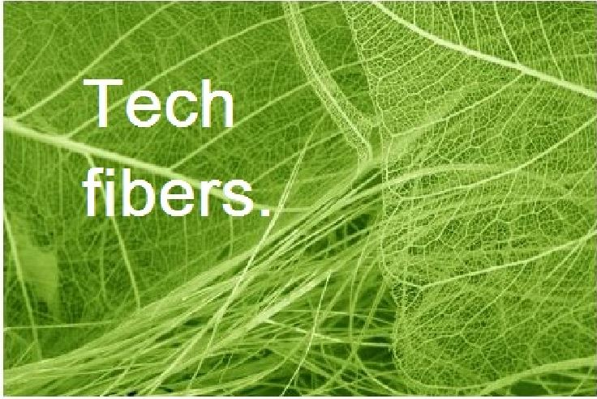

Your Research With Fibres Begins Here.
Tech Fibres is an establishment started in 1991 and the company grown to be a big success with the support from Engineering & Fabric researcher, students and exporters around the globe. Tech Fibre is the sister concern of WindowFashions India and we would like to present here with our high quality and factory tested fibres for your projects, textiles, handicrafts and interior designing.

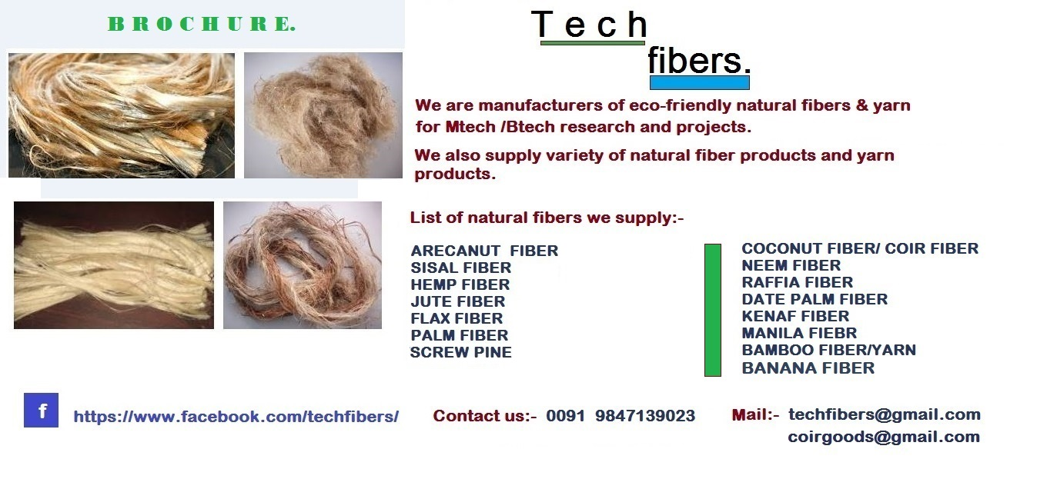
Our fibres have long durability, tensile strength, colour and quality which is very accessible for your researches on various Engineering (ME/BE/M tech/B tech) departments and Textile industries, clothing & fabric designing projects. The fibres are extracted in an organic way from various parts of plants & palms. We provide fibres in Natural and in Eco-friendly colours. We provide fibres in any quantity with best packing in fast and safe courier/shipments.
CALL US/ WHATSAPP:- 0091 9847139023
eMAIL:- techfibers@gmail.com
Fb:- https://www.facebook.com/techfibers/
Web:- www.techfibers.yolasite.com

We provide high quality 100% natural fibres such as Sisal, Hemp, Flax, Jute, Palm, Coconut, Raffia, Date Palm, Kenaf, Manila, Neem, Bamboo, Arecanut, Pineapple etc...
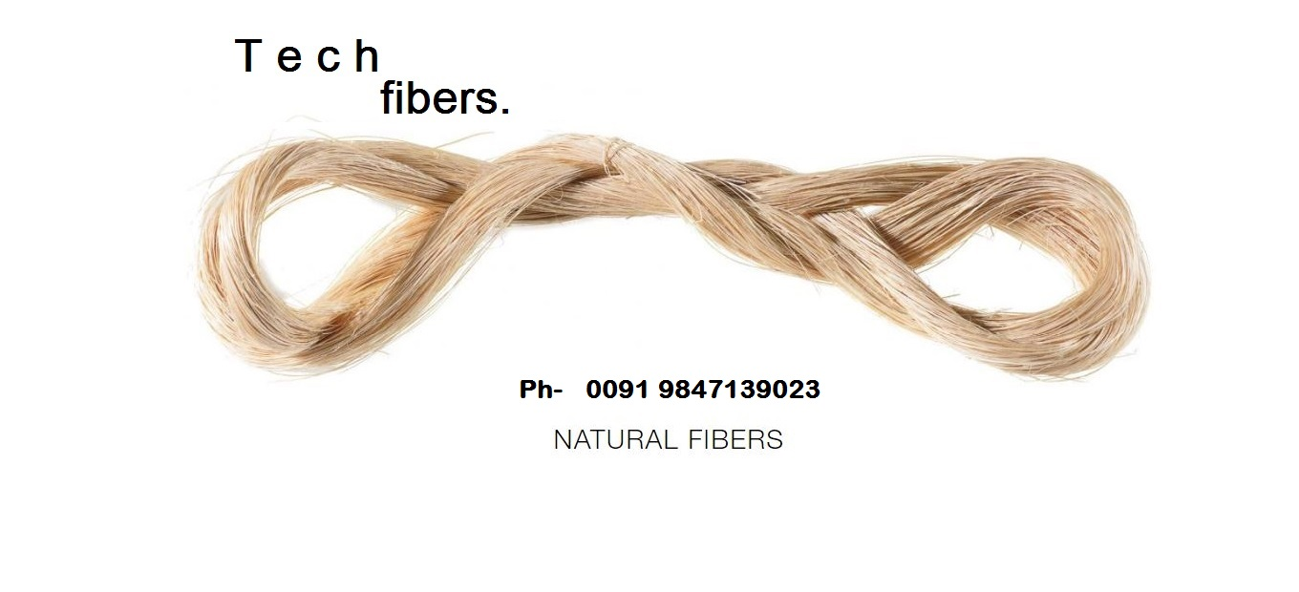

PRODUCT CATALOGUE
FLAX
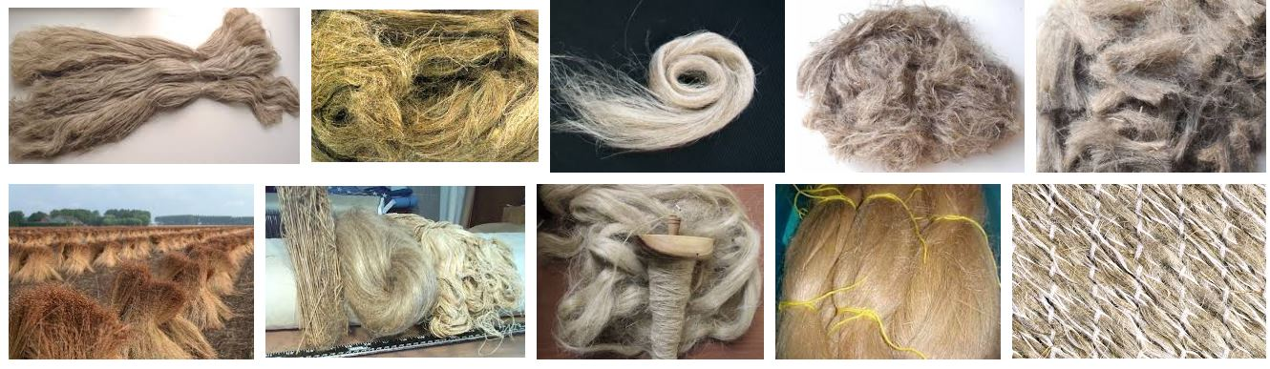
SISAL
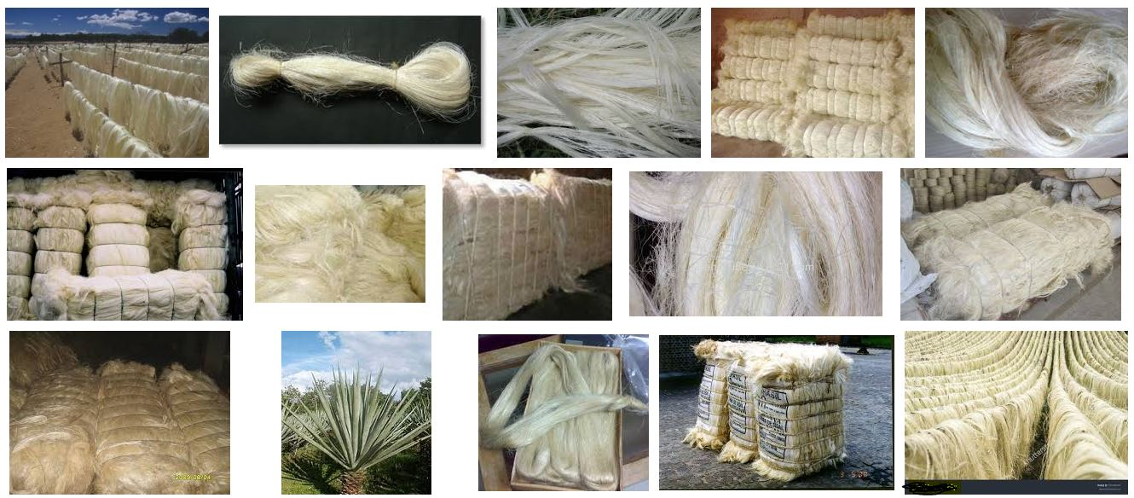

BAMBOO
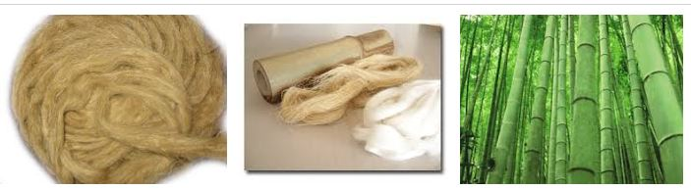

BANANA
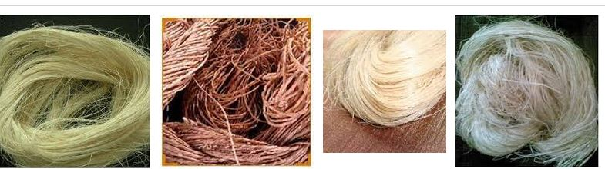

COIR
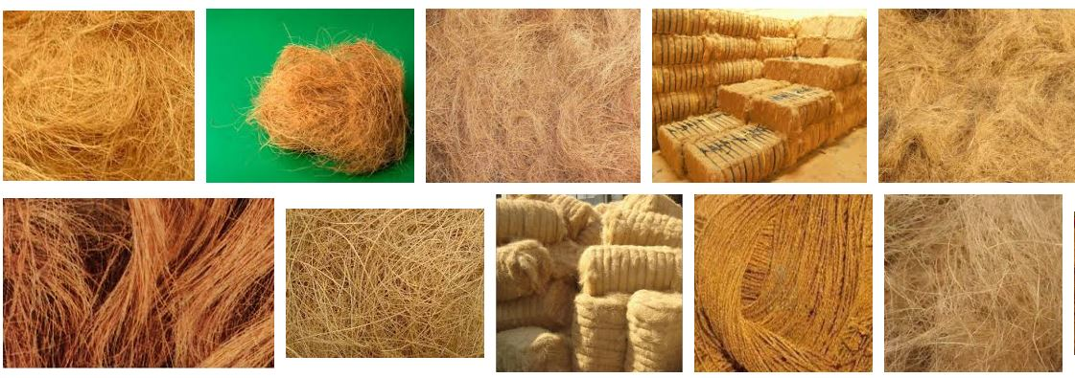

HEMP
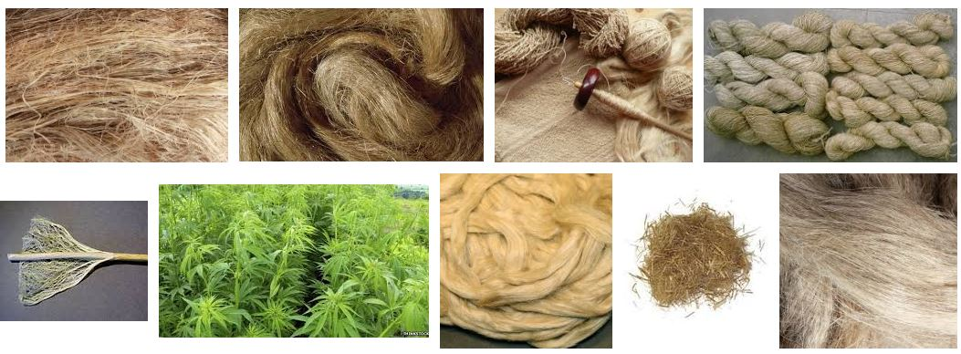

KENAF
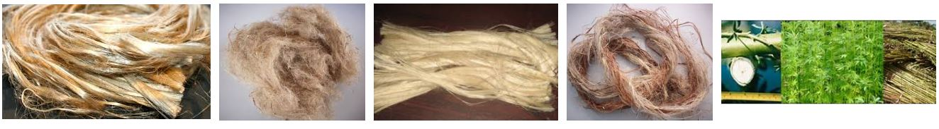

NEEM
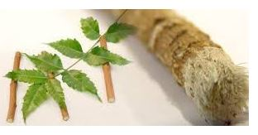

PALM
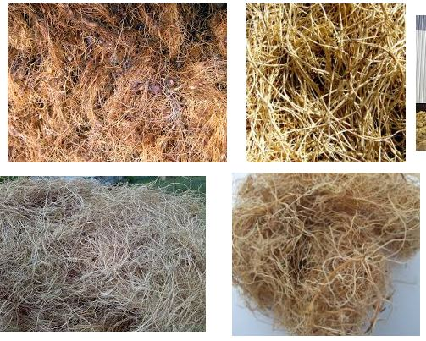

JUTE
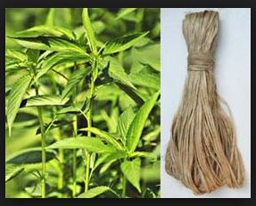

RAFFIA
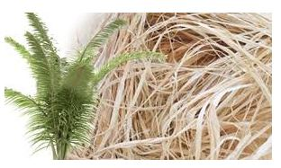

BAMBOO YARN
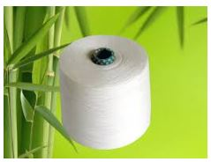
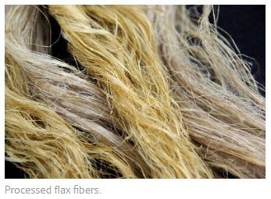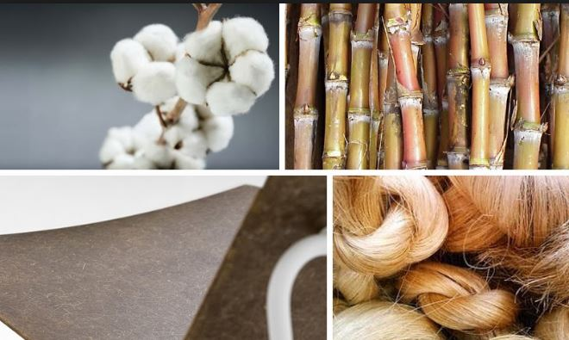

CONTACT US

CALL US/ WHATSAPP:- 0091 9847139023
eMAIL:- techfibers@gmail.com
Fb:- https://www.facebook.com/techfibers/
Web:- www.techfibers.yolasite.com



